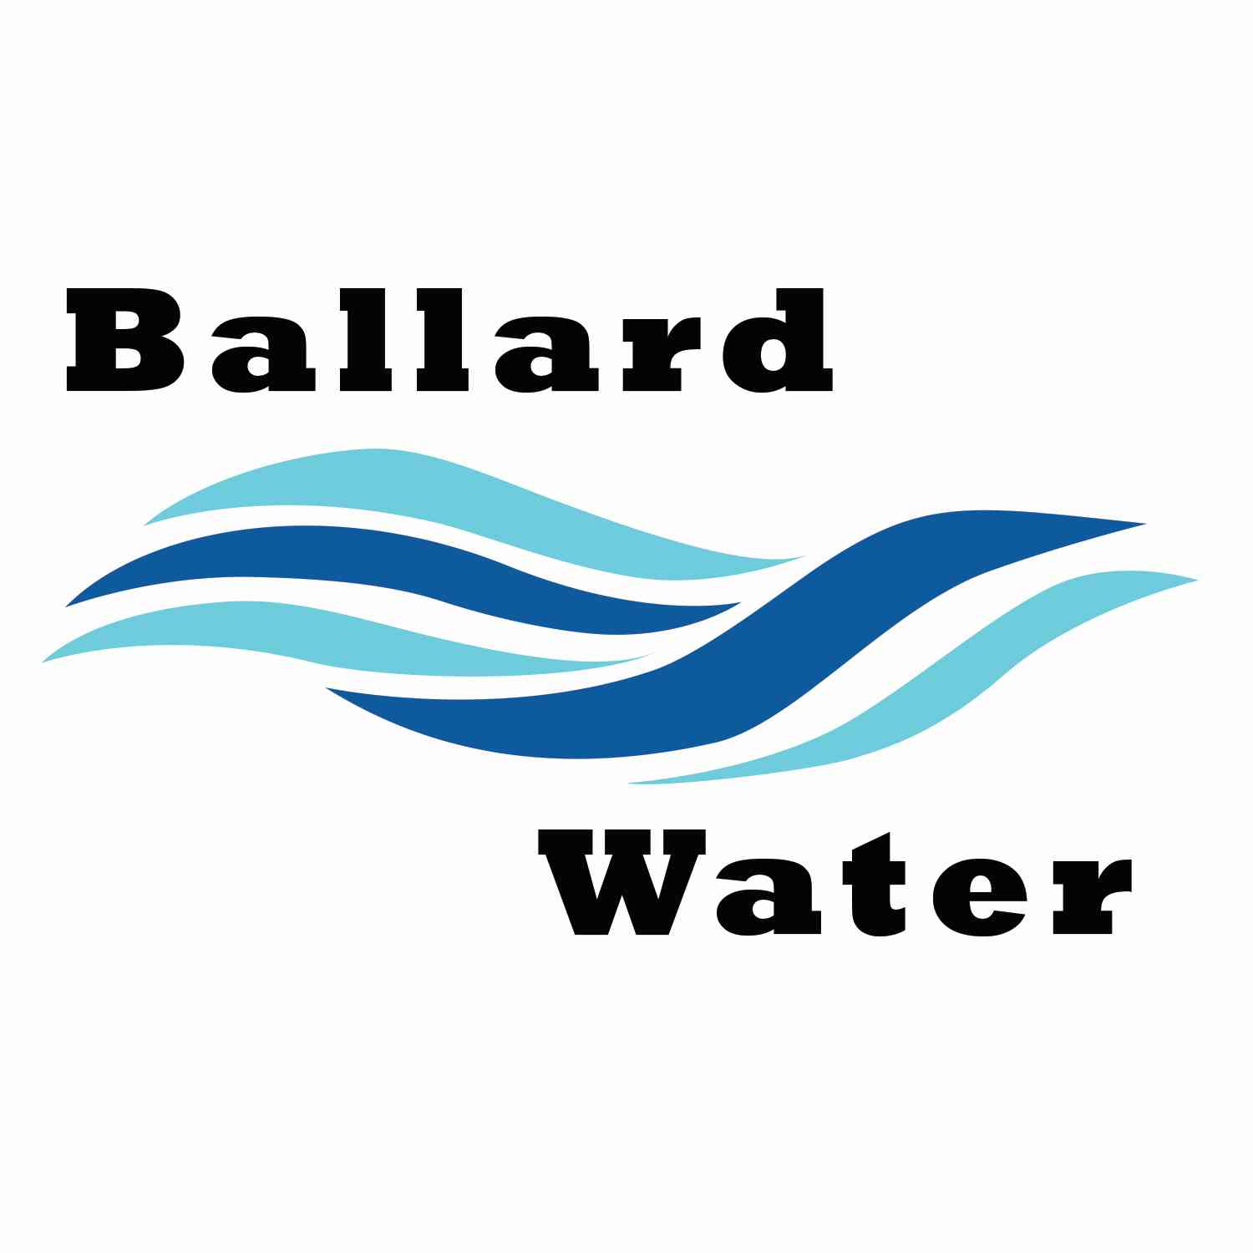

2381 E. 1000 S.

Ballard, UT 84066
Phone: (435) 722-3393
Email: amcdonald@ballardcity.org

Board Chairman

Mark Reidhead

Board Members

Cory O’Driscoll

Andrew Ercanbrack

Ronny Rich

Jesse Danley

Visitors
Craig Nebeker
Al Kettle

Water District Meeting

March 19, 2024, 5:30 pm

MEETING

Item

CALL WATER BOARD MEETING TO ORDER

Welcome and Roll Call – Chairman Mark Reidhead welcomed all in attendance and called roll. Those in attendance include Board Members Cory O’Driscoll, Andrew Ercanbrack, Ronny Rich, Secretaries Anissa McDonald and Kaelyn Meyers. Board Member Jesse Danley was excused from this meeting.

Prayer – Andrew Ercanbrack

Pledge of Allegiance- was said by all present

- ENGINEER PROJECT UPDATES –
Well Project -- Army Corp. needs to write a letter stating that they looked at the property and everything looks good. They have 30 days to respond and then the project can be started. Jones & DeMille will let us know when that is in hand. They would like to go ahead with the bidding process if we feel good about that decision.
The specifications have been sent to the state and they have begun their review. We are looking to bid at the end of April and start drilling in May.

Lead & Copper Project – One of the largest challenges has been getting the meter address to match up with the property address. They have been working with Ben to identify those challenge addresses are not lead pipe. They are getting ready to sort the files in the GIS system. If we have a lot of unknows we can take a water sample of those addresses and if it comes back clean, then we can assume there is no copper in those lines. It is still unknown what the state will do regarding the lines that might need to be changed out. As of right now the state is only looking for service lines.

Potential Sewer Projects – Craig Nebeker stated that the days of getting all grant is not being done right now. The Div of Water Quality has a state revolving fund that would help with sewer lines and sewer treatment plants though. They say that there is still a lot of money available. He stated that a good future development project would be to extend the sewer along highway 40 from 2500 E. heading east. In addition, a project on 3500 E. around 2000 North has been discussed in the past.

- REVIEW & CORRECT MINUTES –
- February 20, 2024
Motion was made by Board Member Cory O’Driscoll to approve the Minutes of February 20, 2024 as written. 2nd by Board Member Andrew Ercanbrack. All in favor.
Yea Nay
Board Members
Mark Reidhead
Cory O’Driscoll
Andrew Ercanbrack
Ronny Rich
Board Member Jesse Danley was excused.

- FOLLOW-UP ON PAST MINUTES
No follow-up at this time

- FINANCES: Checks, Statements, Reports and Budget
Finances were gone over and approved.

- ADJOURN WATER BOARD MEETING
Motion was made by Board Member Ronny Rich to adjourn Water Board Meeting at 6:15 pm. 2nd by Board Member Cory O’Driscoll. All in favor.
Yea Nay
Board Members
Mark Reidhead
Cory O’Driscoll
Andrew Ercanbrack
Ronny Rich
Board Member Jesse Danley was excused.

__________________________________ __________________________
Chairman Mark Reidhead Date

__________________________________ __________________________
Secretary Anissa McDonald Date

